**Reg No. E020-01-0865/2020**



DEDAN KIMATHI UNIVERSITY OF TECHNOLOGY

**SCHOOL OF ENGINEERING ELECTRICAL & ELECTRONIC ENGINEERING DEPARTMENT**

**BSc. TELECOMMUNICATIONS AND INFORMATION ENGINEERING**

**STUDENTS’ EXTERNAL ATTACHMENT LOG-BOOK**

# DURATION: 12 WEEKS

**THE LOG BOOK**

1. INTRODUCTION

This book is to assist the student to keep record of the training. It will show the departments and sections in which the student has worked and the periods of time spend in each.

1. DAILY REPORT

The daily work carried out during the periods of training is to be recorded clearly with sketches and diagrams where applicable.

1. WEEKLY REPORT

This is a summary of work done in a week and should cover theory/practical report on the work covered. Students are required to present the log-book weekly to the industry based supervisor for assessment of content and progress. The Supervisor can use any page for his comments where necessary.

1. CHANGE OF ATTACHMENT

A student is expected to start and finish his industrial attachment in one establishment. If it becomes absolutely necessary that he must change his place of attachment, the student should first secure permission in writing from the university. His application for change of place of attachment should indicate the name and the address (not just Post Office Box) of the company or industry to which he wishes to transfer. Any attachment not properly authorized will be cancelled.

1. COLLEGE SUPERVISOR’S VISIT

The training supervisor of the DKUT will check the log-book. When he/she visits the project to ensure that the proper training is being received, and record his/her comment on the paper provided for this purpose, towards the end of the book.

1. SPECIAL REQUEST FOR THE INDUSTRY-BASED SUPERVISOR Please assess the student as per assessment form provided.
2. REPORT WRITING

In addition to the daily and weekly record the student should submit a summary report of the work done during the attachment duration e.g. full coverage of the course, problems encountered. Suggest improvements to make the program worthwhile. The report should contain a summary of activities of the organization, manufacturing/services processes the student was involved in. This includes the highlights of the project the student is involved in. The student is expected to point out the weak and strong points of the attachment.

1. REPORT SUBMISSION

The log-book and report must be submitted to the relevant departmental Attachment Coordinator at the end of the attachment.

S T U D E N T ‘S P A R T I C U L A R S

Name of student: CHITWA MERLYN ZAWADI

(Surname first)

Registration No. of the student: E020-01-0865/2020

Department: ELECTRICAL AND ELECTRONICS ENGINEERING

Course of study: BSc. TELECOMMUNICATIONS AND INFORMATION ENGINEERING

Year of study: 4TH

Name and Address of Company/Establishment Attached: DEDAN KIMATHI UNIVERSITY OF TECHNOLOGY, CENTRE FOR DEVELOPMENT OF ELECTRONIC DEVICES

P.O.BOX PRIVATE BAG, 10143

Name of Industry-based supervisor: MR. KARANNJA

Duration: From: 08/05/2023 To: 28/07/2023

No. of weeks: 12 WEEKS

{ }

{ }

**Official rubber stamp** { }

{ }

{ }

The student could draw the Organization Chart of industry attached hereunder:

**COMPANY ORGANIZATION**

**ATTACHMENT TIME-PLAN**

(The student should draw a time-table indicating time to be sent on each task/section)

**WEEKLY PROGRESS CHART (WEEK ENDING: ------ ONE )**

|  |  |
| --- | --- |
| DAY | **DESCRIPTION OF WORK DONE** |
| MON | Introduction to the project |
| TUES | Review of the project  Assessment of the work previously done through the available documents |
| WED | A meeting with the group leader to discuss the specifics of the project. |
| THUR | Introduction to KiCAD |
| FRI | Review of the KEBS standards on the speed limiter. |
| SAT | Report Writing |

TRAINEES WEEKLY REPORT

Speed Limiter block diagram

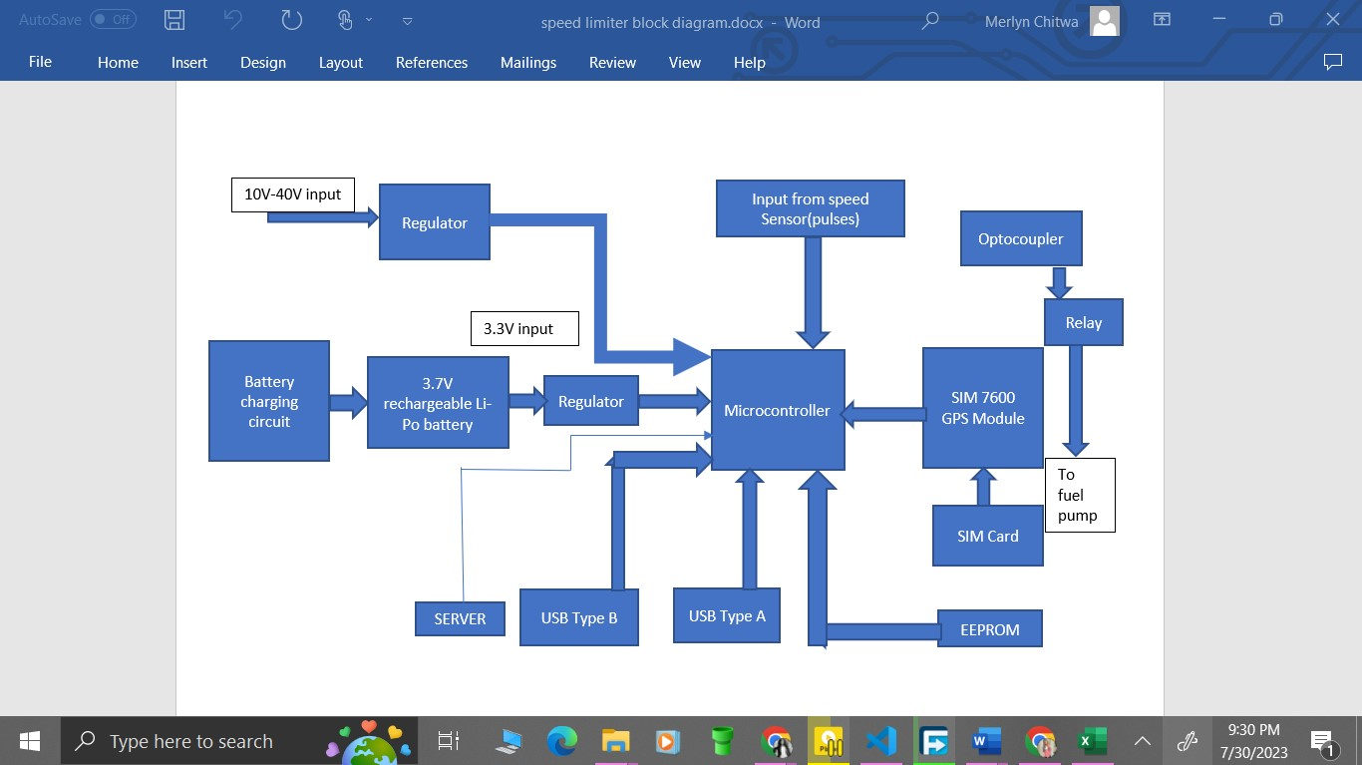

NOTE: USE BACK PAGE FOR THE CONTINUATION OF THE REPORT

## FOR SKETCHES, DIAGRAMS AND GRAPHS DATE: 12/05/2023

(Additional drawings, may be attached where necessary) The student may also use this space for additional reports.

Student’s Signature: …………………………… Date 12/05/2023

Comments by Lecturer/Supervisor:………………………………………………………………..

…………………………………………………………………………………………………………….

……………………………………………………………………………………………………………. Name: ………………………………………………………………………………………………..

Signature:…………………………………….. Date: ………………………………………..…

**WEEKLY PROGRESS CHART WEEK ENDING: -----TWO )**

|  |  |
| --- | --- |
| DAY | **DESCRIPTION OF WORK DONE** |
| MON | Introduction to STM32CudeIDE.  Introduction to STM32 Microcontroller – The Nucleo 144, to be more specific, STM32  NUCLEO-H743ZI2. |
| TUES | Advantages of STM32 for IoT projects  Disadvantages of STM32 for IoT projects |
| WED | Understanding the HAL protocol |
| THUR | Understanding GPIO in STM32 projects  Understanding of the DMA |
| FRI | Understanding UART  Understanding USART  Differences between UART and USART |
| SAT | Report Writing |

## TRAINEES WEEKLY REPORT

By visiting the STMicroelectronics website, the documentation was downloaded and read through to obtain some understanding of how the Nucleo-144 works.

STM32 microcontrollers offer several advantages for IoT projects, but they also have some limitations.

**Advantages of STM32 for IoT projects:**

1. **Low Power Consumption**: STM32 microcontrollers are designed with power efficiency in mind, making them suitable for IoT devices that often run on battery power. They offer various low-power modes to optimize energy consumption.

2. **Rich Peripherals**: STM32 microcontrollers come with a wide range of built-in peripherals, such as GPIOs, UART, SPI, I2C, ADC, DAC, timers, and more. These peripherals facilitate easy interfacing with sensors, actuators, and communication modules, making IoT project development more straightforward.

3. **Robust Ecosystem**: STM32 is backed by STMicroelectronics, a reputable semiconductor company. The STM32 ecosystem provides comprehensive development tools, libraries, and documentation, making it easier for developers to start and complete their projects.

4. **Scalability and Versatility**: STM32 microcontrollers come in a variety of series and models, catering to different performance, memory, and feature requirements. This scalability enables developers to choose the most suitable microcontroller for their specific IoT application.

5. **Wide Community Support**: STM32 has a large community of developers and enthusiasts who actively share knowledge, code, and solutions. Access to online forums and resources can be invaluable when working on IoT projects.

6. **Security Features**: STM32 microcontrollers offer hardware-based security features like secure boot, hardware cryptographic accelerators, and memory protection units, enhancing the security of IoT devices and data.

**Disadvantages of STM32 for IoT projects:**

1. **Learning Curve**: For beginners, the STM32 platform may have a steeper learning curve compared to some other microcontrollers. The extensive range of features and options can be overwhelming initially.

2. **Complexity**: Some IoT projects might require a simpler microcontroller, and STM32 could be considered overkill for such applications. In such cases, choosing a more straightforward microcontroller might be a better fit.

3. **Cost**: While STM32 microcontrollers offer excellent features, they might be more expensive compared to some entry-level microcontrollers. For cost-sensitive IoT projects, this could be a drawback.

4. **Development Tools**: Although STM32 provides a range of development tools, some developers might prefer a different Integrated Development Environment (IDE) or toolchain, and setting up alternative tools can be more challenging.

5. **Power Management in Complex Applications**: While STM32 offers various low-power modes, managing power consumption in complex IoT applications with multiple sensors and communication modules can be more challenging and may require additional power optimization efforts.

**ASPECTS/PROPERTIES OF STM32**

**HAL Protocol:**

The HAL (Hardware Abstraction Layer) protocol is a software layer provided by STMicroelectronics to abstract the complexities of STM32 microcontroller hardware, making it easier for developers to interface with various peripherals and functionalities. HAL provides a standardized API (Application Programming Interface) that allows developers to control and configure the microcontroller's hardware features without directly dealing with low-level register manipulations. This abstraction simplifies the development process, enhances portability across different STM32 microcontrollers, and improves code maintainability.

**GPIO (General Purpose Input/Output):**

GPIO refers to the pins on the STM32 microcontroller that can be configured as either inputs or outputs. These pins provide a versatile means of connecting external devices, such as sensors, actuators, or other microcontrollers. Developers can configure GPIO pins as either digital inputs to read external signals or digital outputs to control external devices. GPIOs are fundamental in many IoT projects, as they serve as the primary means of communication between the microcontroller and the external world.

**DMA (Direct Memory Access):**

DMA is a hardware feature in STM32 microcontrollers that allows data transfer between peripherals and memory without involving the CPU. Instead of relying on CPU involvement for data transfer, DMA takes care of moving data, freeing up the CPU to handle other tasks. This results in faster and more efficient data transfers, making it especially valuable in data-intensive IoT applications where high-speed communication and data handling are critical.

**UART (Universal Asynchronous Receiver/Transmitter):**

UART is a widely used serial communication protocol that enables asynchronous data transmission between two devices. STM32 microcontrollers often include UART hardware, allowing developers to implement point-to-point communication between the microcontroller and external devices, such as sensors or other microcontrollers. UART uses two wires for communication: one for transmitting data (TX) and another for receiving data (RX). It is commonly used for simple, short-distance communication between devices.

**USART (Universal Synchronous/Asynchronous Receiver/Transmitter):**

USART is a more versatile version of UART available in some STM32 microcontrollers. It can operate in both synchronous and asynchronous modes, making it more flexible for various communication scenarios. Like UART, USART also facilitates point-to-point communication between devices, and it can be used for more complex communication requirements. It uses additional clock signals for synchronous communication, which allows for more precise data synchronization.

## FOR SKETCHES, DIAGRAMS AND GRAPHS DATE………………..

(Additional drawings, may be attached where necessary) The student may also use this space for additional reports.

**Differences between UART and USART:**

The primary differences between UART and USART lie in their operational modes and capabilities:

1. **Synchronization:**

- UART is asynchronous, meaning it doesn't use a separate clock signal. Instead, it relies on predefined baud rates for data transmission.

- USART, on the other hand, can operate in both asynchronous and synchronous modes. In synchronous mode, it uses an additional clock signal for data synchronization.

2. **Complexity:**

- UART is simpler and more straightforward, suitable for basic point-to-point communication.

- USART provides more versatility with its synchronous mode, making it better suited for scenarios where precise timing and synchronization are required.

3. **Number of Wires:**

- UART typically requires only two wires (TX and RX) for communication.

- USART requires at least three wires for synchronous communication (TX, RX, and a clock signal), but it can still be used in asynchronous mode with only two wires.

4. **Applications:**

- UART is commonly used for simple, short-distance communication, such as connecting a microcontroller to a GPS module or Bluetooth module.

- USART is preferred when more complex communication is needed, like interfacing with certain displays, industrial communication protocols, or scenarios requiring synchronous data transfer.

In summary, UART is simpler and suitable for straightforward communication, while USART adds synchronous capabilities, making it more versatile and better suited for complex communication scenarios. The choice between UART and USART depends on the specific requirements of the IoT project and the complexity of the communication needed.

Student’s Signature: …………………………… Date…………………………………………..

Comments by Lecturer/Supervisor:………………………………………………………………..

…………………………………………………………………………………………………………….

……………………………………………………………………………………………………………. Name: ………………………………………………………………………………………………..

Signature:…………………………………….. Date: ………………………………………..…

**WEEKLY PROGRESS CHART (WEEK ENDING: ---- THREE )**

|  |  |
| --- | --- |
| DAY | **DESCRIPTION OF WORK DONE** |
| MON | HAL Timers using STM32CubeIDE  Implementing I2C protocol using STM32 and NUCLEO-H743ZI2 |
| TUES | Implementing GPIO using STM32CudeIDE and Nucleo  Implementing DMA using STM32CubeIDE and Nucleo |
| WED | Implementing UART protocol  Implementing USART protocol |
| THUR | Implementing SPI  Implementing ADC |
| FRI | [STM32CubeIDE Potentiometer ADC with STM32H743ZIT6U](https://www.micropeta.com/video16) LCD 1602 I2C Display with STM32H743ZIT6U using STM32CubeIDE I2C |
| SAT | Report writing |

## TRAINEES WEEKLY REPORT

# LCD 1602 I2C Display with Nucleo STM32H743ZIT6U using STM32CubeIDE

### Wiring Diagram

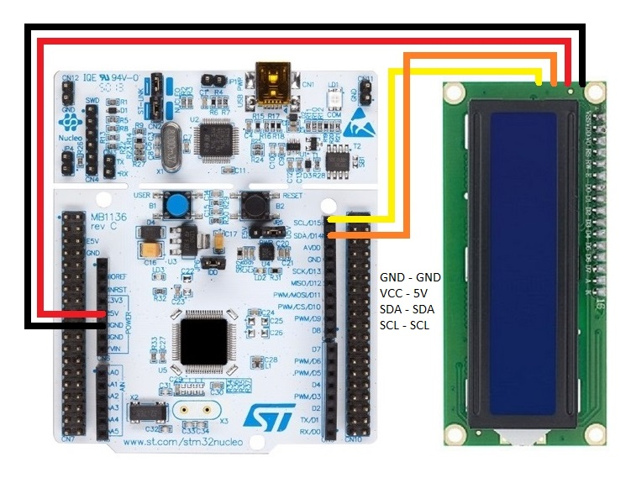

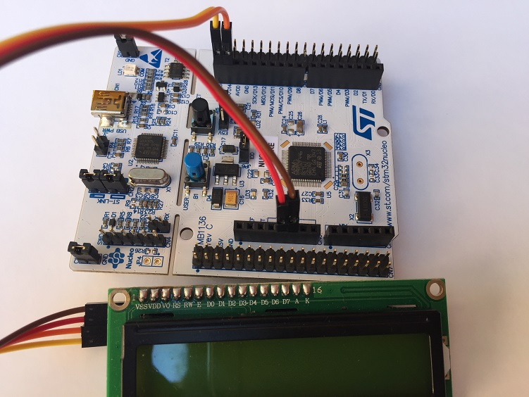

#### STM32CubeIDE Settings

Click connectivity --> Click I2C1

For I2C select I2C

Set PB8 to I2C1_SCL

Set PB9 to I2C1_SDA

#### Libraries

Inside Core/Inc Folder

[liquidcrystal_i2c.h](https://github.com/eziya/STM32_HAL_I2C_HD44780/blob/master/Src/liquidcrystal_i2c.h)

Inside Core/Src Folder

[liquidcrystal_i2c.c](https://github.com/eziya/STM32_HAL_I2C_HD44780/blob/master/Src/liquidcrystal_i2c.c)

Line no 58 of liquidcrystal_i2c.h, change to #define DEVICE_ADDR (0x27 << 1) // 0x4E

#### Additional code on top of STM32CubeIDE generated code

/* USER CODE BEGIN Includes */

#include "liquidcrystal_i2c.h"

/* USER CODE END Includes */

/* USER CODE BEGIN 2 */

HD44780_Init(2);

HD44780_Clear();

HD44780_SetCursor(0,0);

HD44780_PrintStr("HELLO");

HD44780_SetCursor(10,1);

HD44780_PrintStr("WORLD");

HAL_Delay(2000);

HD44780_Clear();

HD44780_SetCursor(0,0);

HD44780_PrintStr("HELLO");

HAL_Delay(2000);

HD44780_NoBacklight();

HAL_Delay(2000);

HD44780_Backlight();

HAL_Delay(2000);

HD44780_Cursor();

HAL_Delay(2000);

HD44780_Blink();

HAL_Delay(5000);

HD44780_NoBlink();

HAL_Delay(2000);

HD44780_NoCursor();

HAL_Delay(2000);

HD44780_NoDisplay();

HAL_Delay(2000);

HD44780_Display();

HD44780_Clear();

HD44780_SetCursor(0,0);

HD44780_PrintStr("Learning STM32 with LCD is fun :-)");

**int** x;

**for**(**int** x=0; x<40; x=x+1)

{

HD44780_ScrollDisplayLeft(); //HD44780_ScrollDisplayRight();

HAL_Delay(500);

}

**char** snum[5];

**for** ( **int** x = 1; x <= 200 ; x++ )

{

itoa(x, snum, 10);

HD44780_Clear();

HD44780_SetCursor(0,0);

HD44780_PrintStr(snum);

HAL_Delay (1000);

}

/* USER CODE END 2 */

## FOR SKETCHES, DIAGRAMS AND GRAPHS DATE………………..

(Additional drawings, may be attached where necessary) The student may also use this space for additional reports.

Button GPIO Interrupt with Nucleo STM32H743ZIT6U using STM32CubeIDE

#### STM32CubeIDE Settings

Set PA1 to GPIO_Output

Set PB1 to GPIO_EXTI1

Click NVIC → EXTI line1 interrupt → Enabled (Tick)

Additional code on top of STM32CubeIDE generated code

/* USER CODE BEGIN PV */

uint32_t previousMillis = 0;

uint32_t currentMillis = 0;

uint32_t counterOutside = 0; //For testing only

uint32_t counterInside = 0; //For testing only

/* USER CODE END PV */

/* USER CODE BEGIN 4 */

**void** HAL_GPIO_EXTI_Callback(uint16_t GPIO_Pin)

{

counterOutside++; //For testing only

currentMillis = HAL_GetTick();

**if** (GPIO_Pin == GPIO_PIN_1 && (currentMillis - previousMillis > 10))

{

counterInside++; //For testing only

HAL_GPIO_TogglePin(GPIOA, GPIO_PIN_1);

previousMillis = currentMillis;

}

}

Student’s Signature: …………………………… Date…………………………………………..

Comments by Lecturer/Supervisor:………………………………………………………………..

…………………………………………………………………………………………………………….

……………………………………………………………………………………………………………. Name: ………………………………………………………………………………………………..

Signature:…………………………………….. Date: ………………………………………..…

**WEEKLY PROGRESS CHART (WEEK ENDING: ----FOUR )**

|  |  |
| --- | --- |
| DAY | **DESCRIPTION OF WORK DONE** |
| MON | Writing STM32CubeIDE code to send potentiometer data to cloud using Thingspeak |
| TUE | Implementing the previously written code to send potentiometer data to Thingspeak |
| WED | Writing STM32CubeIDE code to send data to AWS IoT core using MQTT |
| THUR | Implementing previously written STM32CubeIDE code to send potentiometer data to AWS IoT core |
| FRI | Correcting the errors encountered in the above code |
| SAT | Report writing |

## TRAINEES WEEKLY REPORT

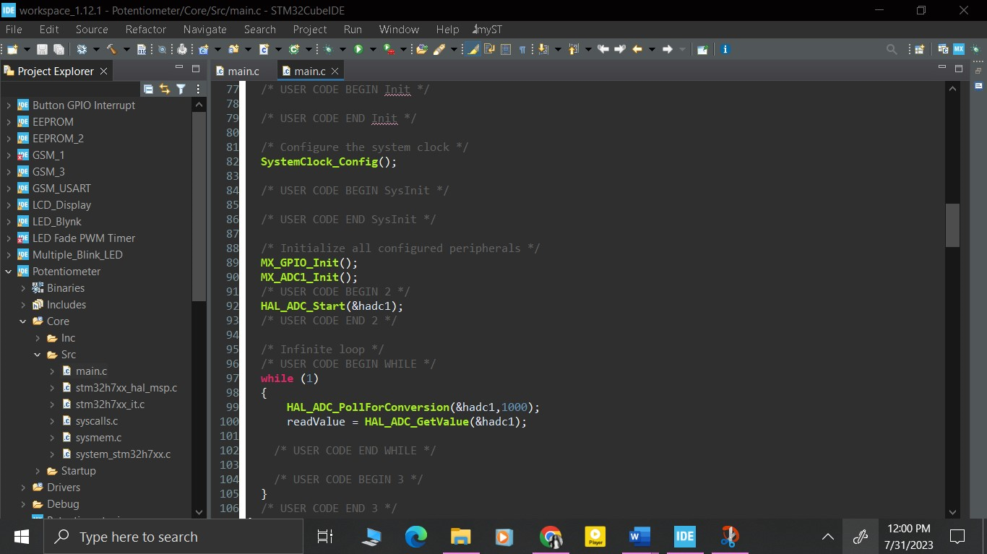

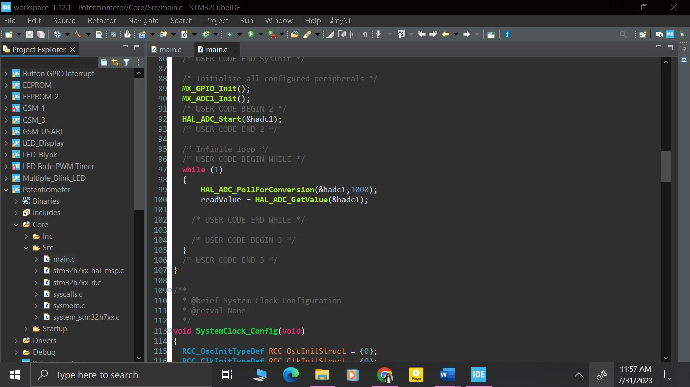

NOTE: USE BACK PAGE FOR THE CONTINUATION OF THE REPORT

## FOR SKETCHES, DIAGRAMS AND GRAPHS DATE………………..

(Additional drawings, may be attached where necessary) The student may also use this space for additional reports.

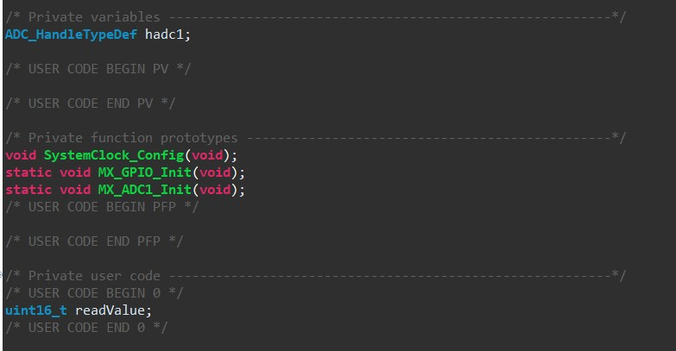

Student’s Signature: …………………………… Date…………………………………………..

Comments by Lecturer/Supervisor:………………………………………………………………..

…………………………………………………………………………………………………………….

……………………………………………………………………………………………………………. Name: ………………………………………………………………………………………………..

Signature:…………………………………….. Date: ………………………………………..…

**WEEKLY PROGRESS CHART (WEEK ENDING: ----FIVE )**

|  |  |
| --- | --- |
| DAY | **DESCRIPTION OF WORK DONE** |
| MON | Writing STM32CubeIDE code to send data to Thingspeak using GSM module |
| TUES | Debugging the code |
| WED | Correcting the remaining errors obtained from the code |
| THUR | Implementing the code written code written the previous day |
| FRI | Improving the efficiency of the code |
| SAT | Report writing |

## TRAINEES WEEKLY REPORT

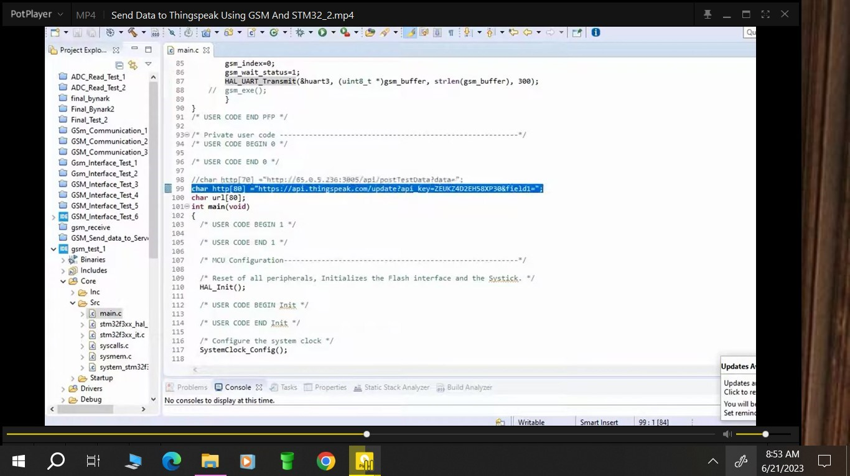

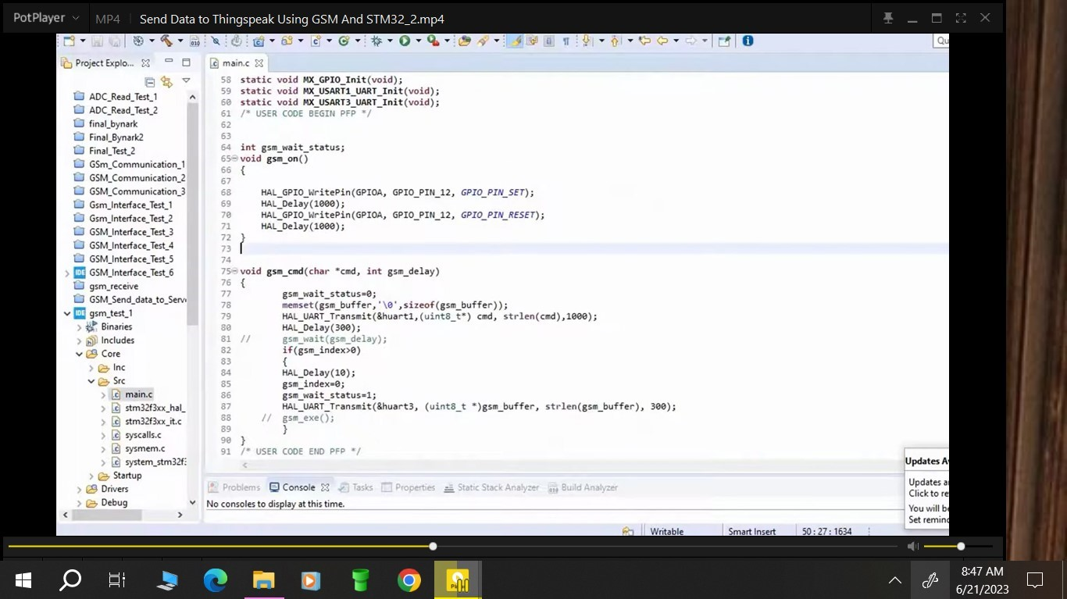

## FOR SKETCHES, DIAGRAMS AND GRAPHS DATE………………..

(Additional drawings, may be attached where necessary) The student may also use this space for additional reports.

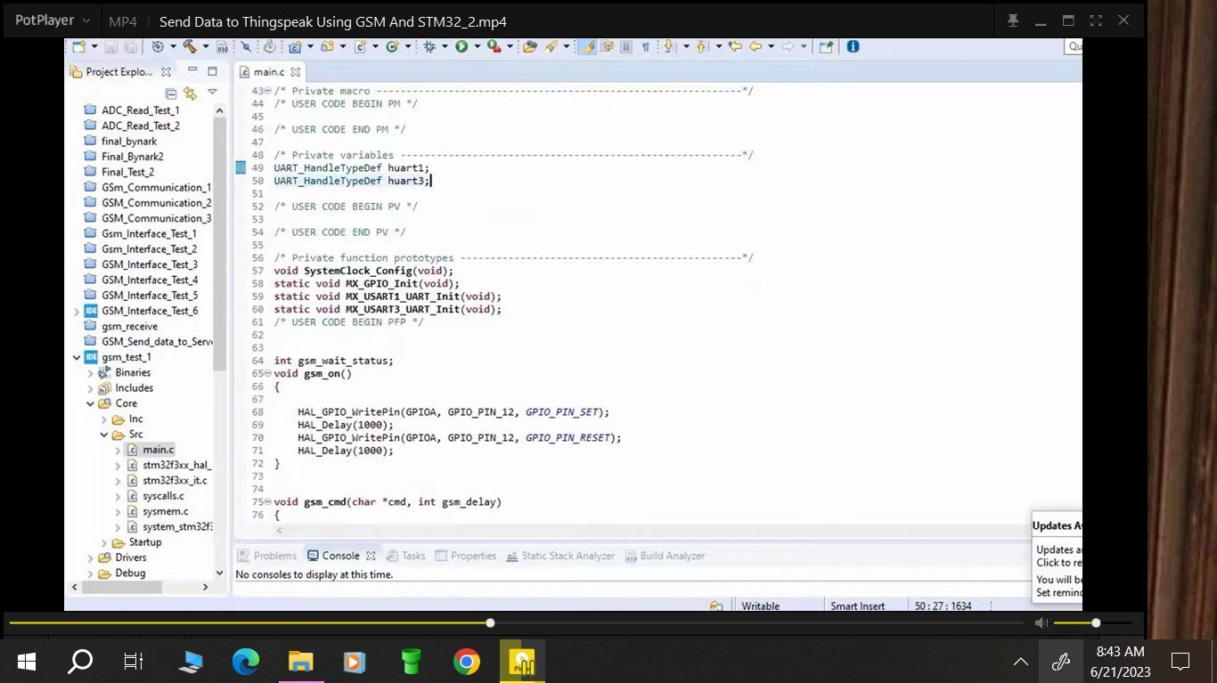

Student’s Signature: …………………………… Date…………………………………………..

Comments by Lecturer/Supervisor:………………………………………………………………..

…………………………………………………………………………………………………………….

……………………………………………………………………………………………………………. Name: ………………………………………………………………………………………………..

Signature:…………………………………….. Date: ………………………………………..…

**WEEKLY PROGRESS CHART (WEEK ENDING: -----SIX )**

|  |  |
| --- | --- |
| DAY | **DESCRIPTION OF WORK DONE** |
| MON | Understanding EEPROM storage |
| TUES | Researching types of EPROM suitable for the project |
| WED | Writing STM32CubeIDE code to ensure data storage on the EEPROM |
| THUR | Debugging the data storage on EEPROM code written the previous day |
| FRI | Implementing the EEPROM data storage |
| SAT | Report writing |

## TRAINEES WEEKLY REPORT

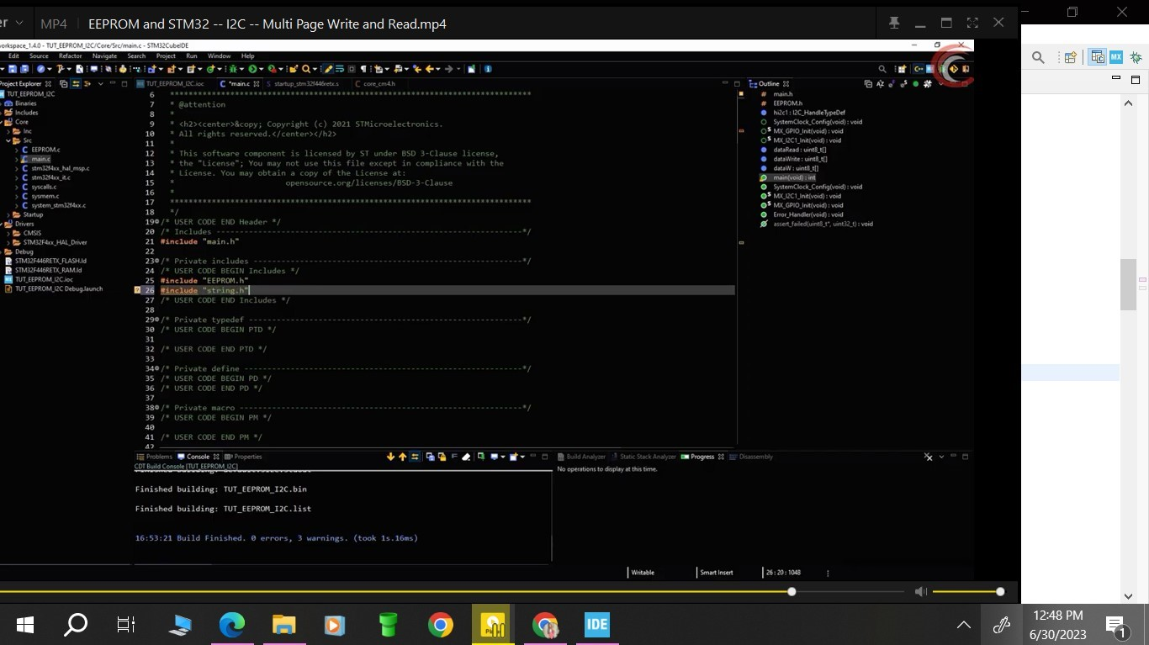

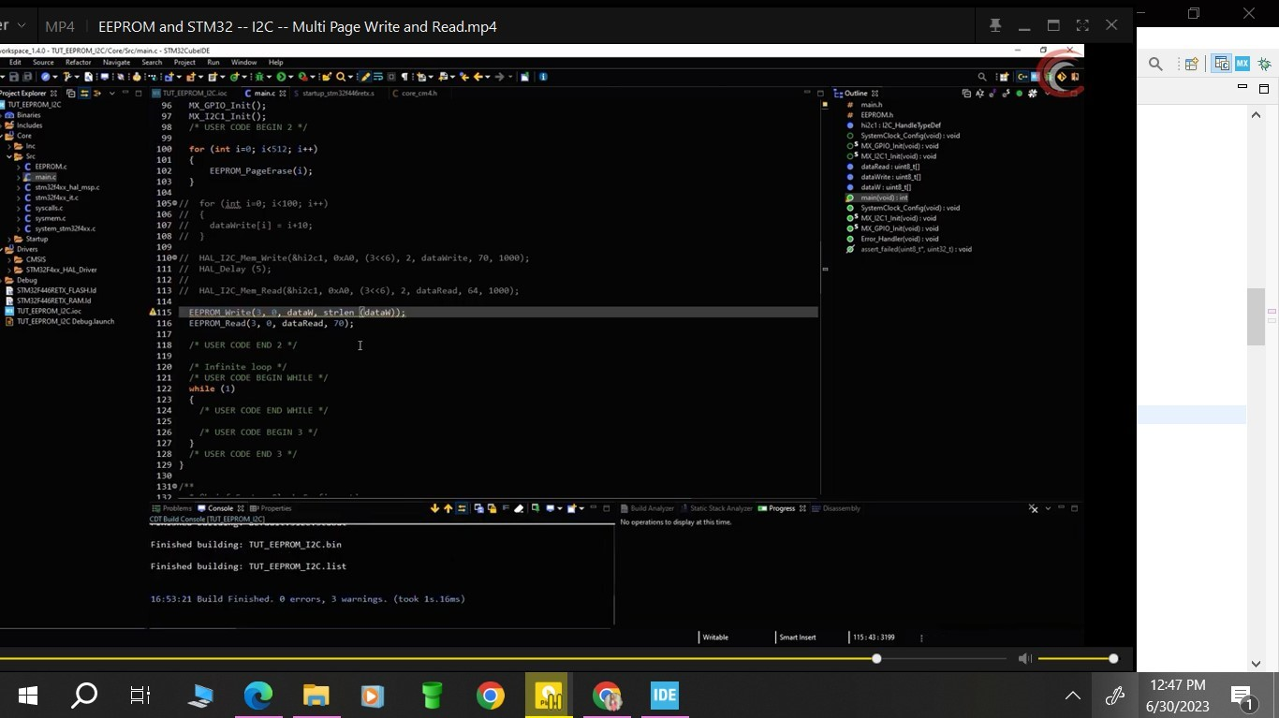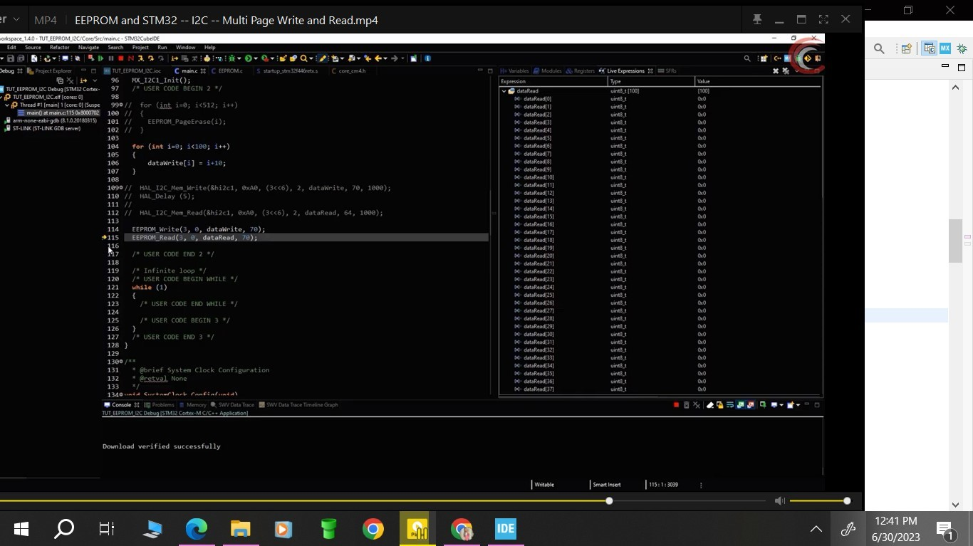

**Advantages of EEPROM**

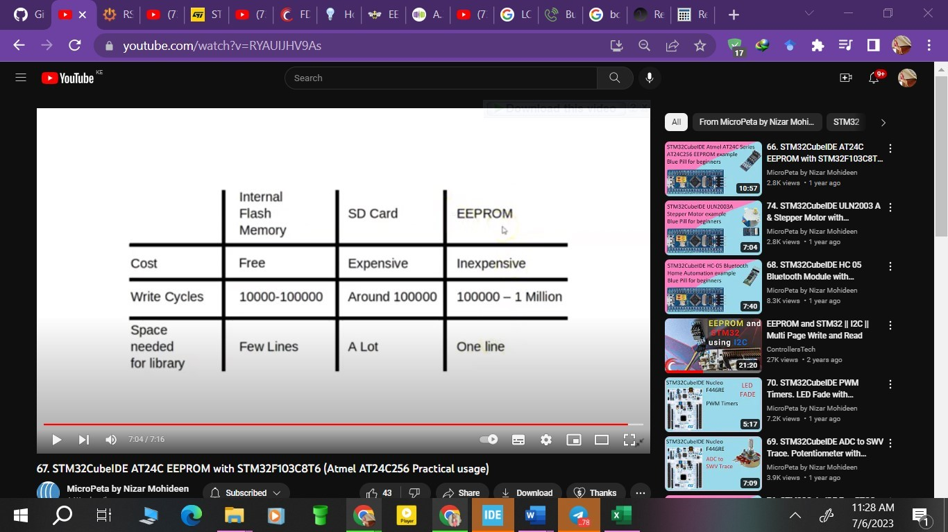

NOTE: USE BACK PAGE FOR THE CONTINUATION OF THE REPORT

## FOR SKETCHES, DIAGRAMS AND GRAPHS DATE………………..

(Additional drawings, may be attached where necessary) The student may also use this space for additional reports.

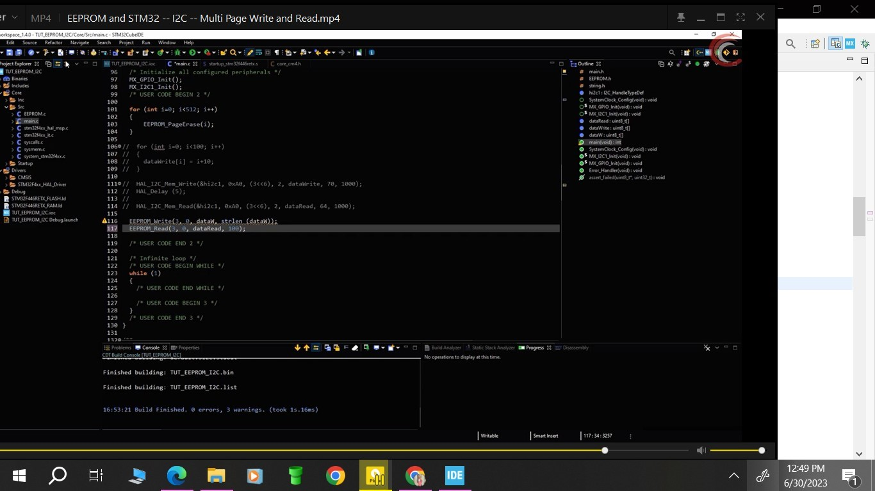

Student’s Signature: …………………………… Date…………………………………………..

Comments by Lecturer/Supervisor:………………………………………………………………..

…………………………………………………………………………………………………………….

……………………………………………………………………………………………………………. Name: ………………………………………………………………………………………………..

Signature:…………………………………….. Date: ………………………………………..…

**WEEKLY PROGRESS CHART (WEEK ENDING: ----SEVEN )**

|  |  |
| --- | --- |
| DAY | **DESCRIPTION OF WORK DONE** |
| MON | USB Type A understanding |
| TUES | Understanding the RS232 protocol |
| WED | Writing code to implement the RS232 protocol |
| THUR | Debugging the RS232 code |
| FRI | Implementing the RS232 protocol |
| SAT | Report writing |

## TRAINEES WEEKLY REPORT

**RS232**

**What is serial communication protocol?** *Serial communication* is the term used in telecommunication and computer science to define the process of sending data sequentially over a communication channel, one bit at a time. Serial communication protocols are rules that govern how this communication will take place. In today’s technology, the use of USB connectivity provides a broader and more functional USB Serial communication for RS232, RS422, and RS485 protocols and devices.

**Types of USB to Serial Communication Protocols**

**RS232**: This protocol defines the meaning, electrical characteristics (voltage level, signaling[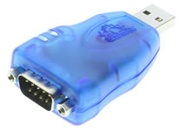](https://www.usbgear.com/USBG-232MINI.html)

rate, maximum load capacitance), and timing of signals between data terminal equipment and data circuit-terminating equipment. In other words, it is an interface for connecting modems and data receiving devices (GPS receivers, data loggers, etc.) to computers. However, RS232 does not define elements such as framing or encoding of characters, bit rates for transmission and error detection protocols.

**Voltage levels**: The voltage levels correspond to logical one and logical zero levels and valid signals are in the range of -3 to +15 volts or -3 to -15 volts. The invalid ranges are -3 to +3 volts.

**Limitations of RS232**

Some of the limitations include:

* + It does not address the possibility of connecting a DTE directly to DTE or a DCE to a DCE.
  + The handshaking of the protocol is intended for setup and takedown of communication circuit only, which is not suitable for the flow control in many devices.
  + The devised multi-drop has limitations in compatibility and speed.
  + Increased power consumption and complicated power supply design are major problems caused due to large voltage swings.
  + There is no specified method for sending power to a device.

RS232 Serial Communication Protocol is used for connection between a data terminal equipment such as a computer terminal, and a data circuit-terminating equipment or data communication equipment, such as a modem.

NOTE: USE BACK PAGE FOR THE CONTINUATION OF THE REPORT

## FOR SKETCHES, DIAGRAMS AND GRAPHS DATE………………..

(Additional drawings, may be attached where necessary) The student may also use this space for additional reports.

## **Pin diagram of RS232 connector**

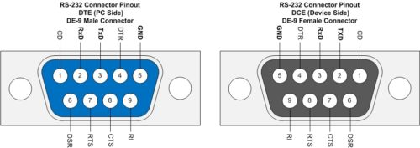

Student’s Signature: …………………………… Date…………………………………………..

Comments by Lecturer/Supervisor:………………………………………………………………..

…………………………………………………………………………………………………………….

……………………………………………………………………………………………………………. Name: ………………………………………………………………………………………………

Signature:…………………………………….. Date……………………………………………..

**WEEKLY PROGRESS CHART (WEEK ENDING: ----EIGHT )**

|  |  |
| --- | --- |
| DAY | **DESCRIPTION OF WORK DONE** |
| MON | Understanding the constant listening function in USB |
| TUES | Researching on how to implement constant listening function in the project |
| WED | Writing code to enable constant listening function in our project |
| THUR | Implementing constant listening function in the speed limiter project |
| FRI | Ensuring data is sent to the printer |
| SAT | Report writing |

## TRAINEES WEEKLY REPORT

**CONSTANT LISTENING FUNCTION**

The term "constant listening function" refers to a feature or functionality in a device that allows it to continuously monitor and be receptive to incoming communication or data from the printer. The device (e.g., a microcontroller or a computer) remains in an active state, ready to receive and process data from the printer whenever the printer sends information.

In practical terms, the constant listening function means that the device is always "listening" for any data or commands coming from the printer. This is typically done through a communication interface, such as USB, UART, Ethernet, or any other supported communication protocol.

When the device is in this constant listening mode, it can quickly respond to any data sent by the printer and take appropriate actions. For example, if the printer sends print data, the device can process and forward that data to the appropriate printer driver or hardware for printing. Similarly, if the printer sends status updates or error messages, the device can process and display or log that information as needed.

The constant listening function is crucial in scenarios where real-time or near-real-time communication between the device and the printer is required. It enables seamless and efficient data exchange between the two devices without the need for manual intervention.

However, it's essential to implement the constant listening function efficiently to avoid unnecessary power consumption or processing overhead. Depending on the specific requirements, the implementation may involve a non-blocking (asynchronous) approach where the device checks for incoming data in a loop without halting its other operations.

In summary, the "constant listening function" ensures that the device remains actively receptive to printer communication, enabling timely and smooth data exchange between the device and the printer, enhancing the overall functionality and usability of the system.

NOTE: USE BACK PAGE FOR THE CONTINUATION OF THE REPORT

## FOR SKETCHES, DIAGRAMS AND GRAPHS DATE………………..

(Additional drawings, may be attached where necessary) The student may also use this space for additional reports.

CONSTANT LISTENING FUNCTION CODE SNIPPET

#include "stm32h7xx.h"

#include "usbd_cdc_if.h"

// Function prototypes

void USB_RX_Callback(uint8_t* Buf, uint32_t Len);

void UART_PrintToPrinter(const char* data);

int main(void)

{

// Initialize HAL, peripherals, and USB communication

HAL_Init();

// Initialize peripherals (e.g., GPIOs, UART, etc.) required for printer communication

// Initialize UART communication for communication with the USB-to-UART bridge

// Initialize USB CDC

MX_USB_DEVICE_Init();

while (1)

{

// Check for received USB data (USB_RX_Callback will be called when data is received)

// This could be a blocking or non-blocking operation based on your requirements.

// Example: Non-blocking implementation

if (CDC_Receive_FS((uint8_t*)RxBuffer, &RxLength) == USBD_OK)

{

USB_RX_Callback(RxBuffer, RxLength);

}

}

}

// USB receive callback function

void USB_RX_Callback(uint8_t* Buf, uint32_t Len)

{

// Handle received data (e.g., printing to the printer via UART)

UART_PrintToPrinter((const char*)Buf);

}

// Function to send data to the printer via UART

void UART_PrintToPrinter(const char* data)

{

// Implement the necessary UART communication code to send data to the printer.

// This will involve sending the data character by character or using UART DMA.

// You'll need to configure the UART port (e.g., baud rate, data bits, stop bits, etc.)

// to match the settings of the USB-to-UART bridge chip.

// Example code to send data character by character:

const char* ptr = data;

while (*ptr != '\0')

{

// Send the character via UART (replace USARTx with the appropriate UART instance)

HAL_UART_Transmit(&huart1, (uint8_t*)ptr, 1, HAL_MAX_DELAY);

ptr++;

}

}

Student’s Signature: …………………………… Date…………………………………………..

Comments by Lecturer/Supervisor:………………………………………………………………..

…………………………………………………………………………………………………………….

……………………………………………………………………………………………………………. Name: ………………………………………………………………………………………………

Signature:…………………………………….. Date……………………………………………..

**WEEKLY PROGRESS CHART (WEEK ENDING: ----NINE )**

|  |  |
| --- | --- |
| DAY | **DESCRIPTION OF WORK DONE** |
| MON | USB type B introduction |
| TUES | Understanding the USB type B |
| WED | Understanding the protocols used in USB Type B |
| THUR | Understanding the involved interrupt mode  Writing code for enabling involved interrupt mode |
| FRI | Implementing the involved interrupt mode |
| SAT | Report writing |

## TRAINEES WEEKLY REPORT

**USB TYPE B**

USB Type B is a commonly used connector in the field of technology, particularly in the context of IoT (Internet of Things) devices. It is one of the various USB connector types and serves as the interface between devices and peripherals for data transfer and power delivery. Here are the key points to know about USB Type B:

1. Connector Type: USB Type B features a trapezoidal shape with a distinctive squarish end. It typically has 4 or 5 pins arranged in a rectangular pattern, allowing for a secure and reliable connection.

2. Receptacle: The USB Type B connector is commonly found on peripheral devices such as printers, scanners, external hard drives, and other devices that require a host connection.

3. Purpose: It is used for data transfer, enabling the exchange of information between the host device (e.g., a computer) and the peripheral device. Additionally, it supports power delivery, allowing the host device to supply power to the peripheral.

4. Variants: There are different variants of USB Type B connectors. The most common are Standard-B and Mini-B. The Standard-B is larger and more prevalent, while the Mini-B is smaller and often used in older devices. There is also a Micro-B variant that is even smaller and found in modern smartphones, tablets, and other compact devices.

5. Speed: USB Type B connectors are used with various USB standards, including USB 2.0, USB 3.0 (also known as USB 3.1 Gen 1), and USB 3.1 (also known as USB 3.1 Gen 2). Each standard provides different data transfer speeds and capabilities.

6. Relevance to IoT: In the context of IoT, USB Type B may be used to connect IoT devices to host devices for data exchange, firmware updates, or charging. However, with the rise of wireless communication technologies like Wi-Fi and Bluetooth, USB connectors may be less prevalent in certain IoT applications.

7. Future Trends: As technology advances, USB Type B connectors are gradually being replaced by newer USB-C connectors, which offer additional benefits such as reversible plug orientation and higher data transfer speeds. However, USB Type B remains in use for many legacy devices and applications.

NOTE: USE BACK PAGE FOR THE CONTINUATION OF THE REPORT

## FOR SKETCHES, DIAGRAMS AND GRAPHS DATE………………..

(Additional drawings, may be attached where necessary) The student may also use this space for additional reports.

**Advantages of using USB Type B**

1. Established Standard: USB Type B is a well-established standard in the industry, making it widely recognized and compatible with a broad range of devices.

2. Sturdy Connection: The trapezoidal shape and square end of USB Type B provide a secure and stable connection, reducing the likelihood of accidental disconnection during data transfer or charging.

3. Versatility: USB Type B can be used for both data transfer and power delivery, making it convenient for various peripherals that require both functionalities.

4. Cost-Effectiveness: USB Type B connectors are generally cost-effective, which is beneficial for manufacturers and consumers alike.

5. Wide Adoption: Many legacy devices and peripherals still use USB Type B connectors, ensuring backward compatibility and ease of integration with older technology.

**Disadvantages of using USB Type B**

1. Size and Bulkiness: Compared to newer USB connector types like USB Type C, USB Type B connectors are relatively large and bulky. This can be a drawback for compact and slim devices where space is limited.

2. Limited Data Transfer Speeds: USB Type B connectors are commonly associated with older USB standards, such as USB 2.0, which offer slower data transfer rates compared to newer standards like USB 3.0 or USB 3.1.

3. Non-Reversible: USB Type B connectors have a specific orientation, meaning they must be inserted in the correct direction. This can be inconvenient when compared to reversible connectors like USB Type C.

4. Durability Concerns: Frequent plugging and unplugging of USB Type B connectors can lead to wear and tear over time, potentially affecting the reliability of the connection.

5. Gradual Phasing Out: With the emergence of USB Type C connectors, USB Type B is gradually being phased out in favor of the newer and more versatile standard. This may limit its long-term viability in the fast-evolving technology landscape.

6. Limited Power Delivery: While USB Type B can handle power delivery, it has limitations compared to the USB Type C Power Delivery (PD) standard, which can deliver higher power levels for charging larger devices.

// Include necessary headers

#include "usbd_core.h"

#include "usbd_hid.h"

#include "usbd_desc.h"

#include "usbd_hid_desc.h"

#include "usbd_conf.h"

// USB Device Core handle declaration

USBD_HandleTypeDef hUsbDeviceFS;

// Initialize USB Device

MX_USB_DEVICE_Init();

// Start USB Device

if (USBD_Start(&hUsbDeviceFS) != USBD_OK) {

Error_Handler();

// Initialize USB Device Library

USBD_Init(&hUsbDeviceFS, &FS_Desc, DEVICE_FS);

// Initialize HID Class

USBD_RegisterClass(&hUsbDeviceFS, &USBD_HID);

// Add custom HID endpoints

USBD_HID_RegisterInterface(&hUsbDeviceFS, &USBD_HID_CustomHID_fops);

// Start USB Device Library

USBD_Start(&hUsbDeviceFS);

}

// USB_IRQHandler

void USB_IRQHandler(void) {

HAL_PCD_IRQHandler(hUsbDeviceFS.pData);

}

Student’s Signature: …………………………… Date…………………………………………..

Comments by Lecturer/Supervisor:………………………………………………………………..

…………………………………………………………………………………………………………….

……………………………………………………………………………………………………………. Name: ………………………………………………………………………………………………

Signature:…………………………………….. Date……………………………………………..

**WEEKLY PROGRESS CHART (WEEK ENDING: -----TEN )**

|  |  |
| --- | --- |
| DAY | **DESCRIPTION OF WORK DONE** |
| MON | Meeting with the team leader |
| TUES | Revisiting the GSM module to enable efficient data transmission to Thingspeak.  This is because the transmission so far had been in intermittent bursts. |
| WED | Understanding the AT-commands necessary for efficient data transmission to ThingSpeak |
| THUR | Rewriting the code necessary for successful transmission using USART1 |
| FRI | Implementing the code |
| SAT | Report writing |

## TRAINEES WEEKLY REPORT

## The ATcommands needed for GSM transmission

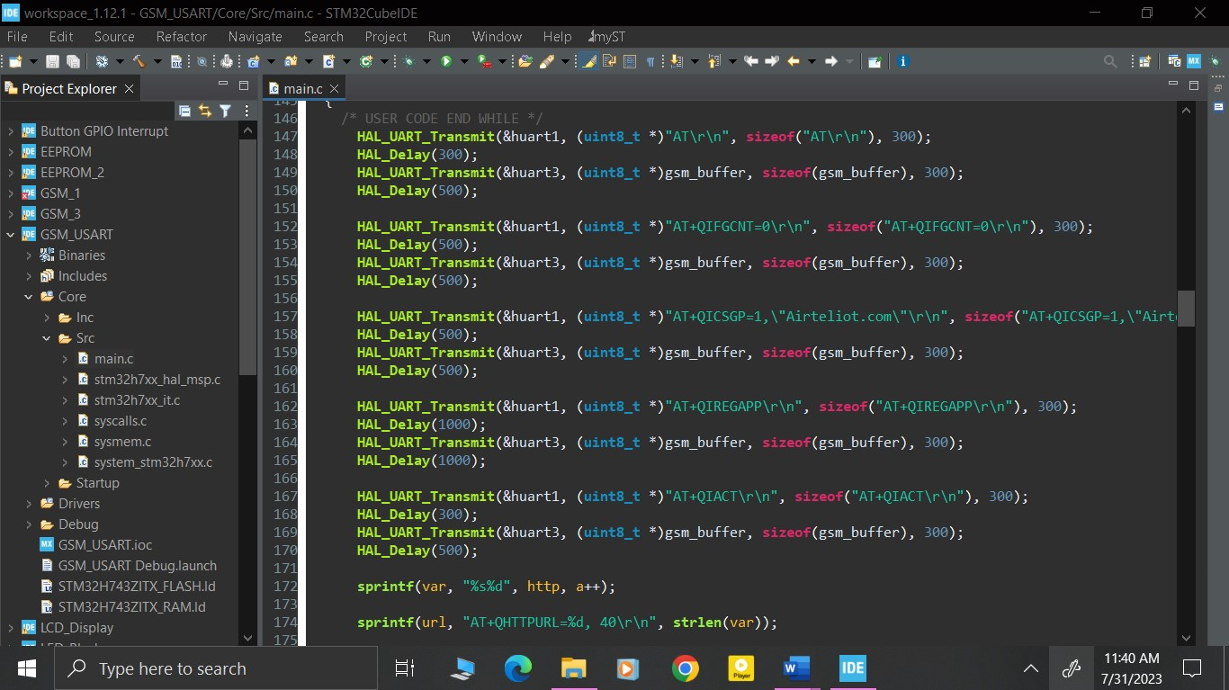

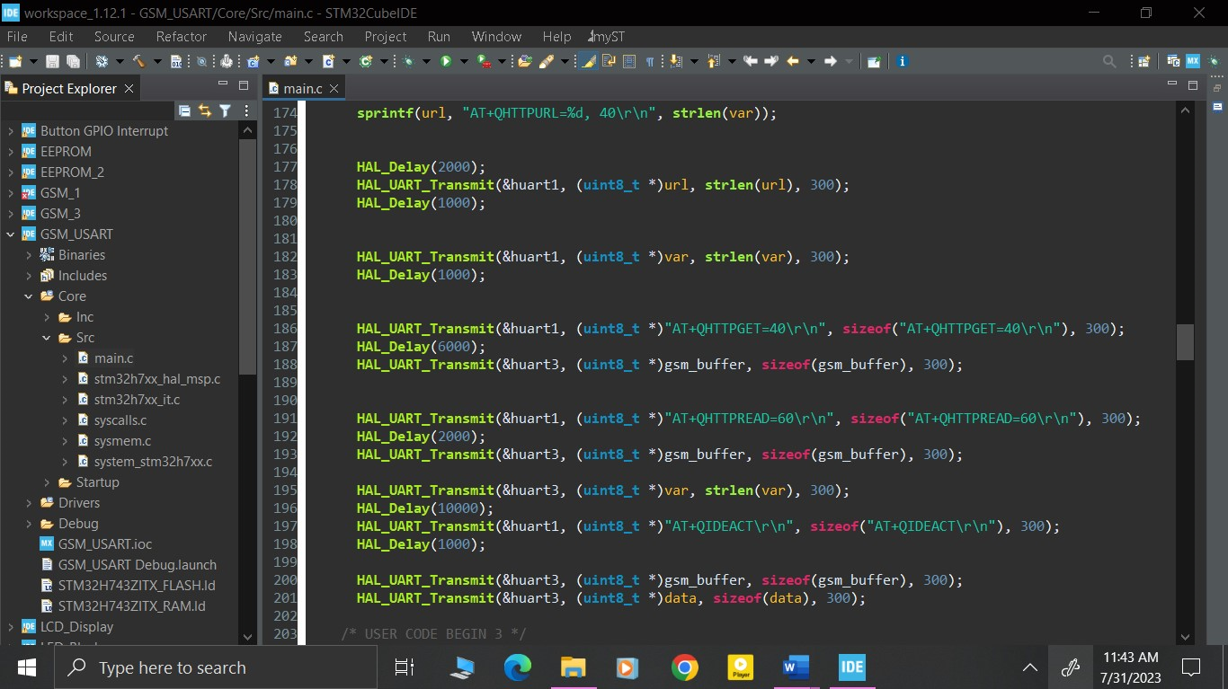

NOTE: USE BACK PAGE FOR THE CONTINUATION OF THE REPORT

## FOR SKETCHES, DIAGRAMS AND GRAPHS DATE………………..

(Additional drawings, may be attached where necessary) The student may also use this space for additional reports.

Additional code other than the AT commands and the STM32 generated code

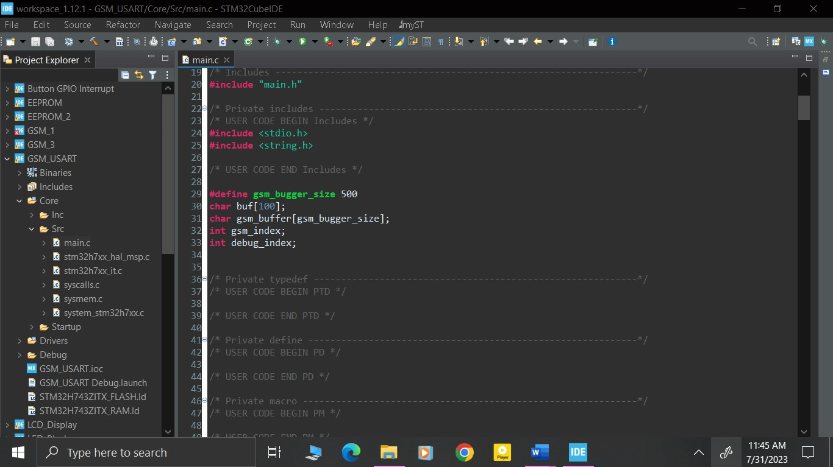

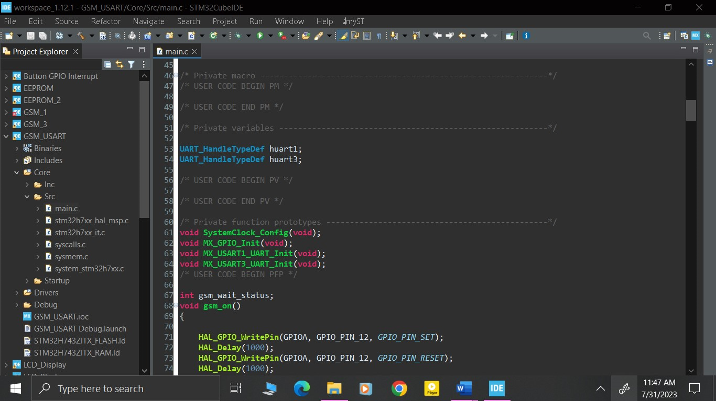

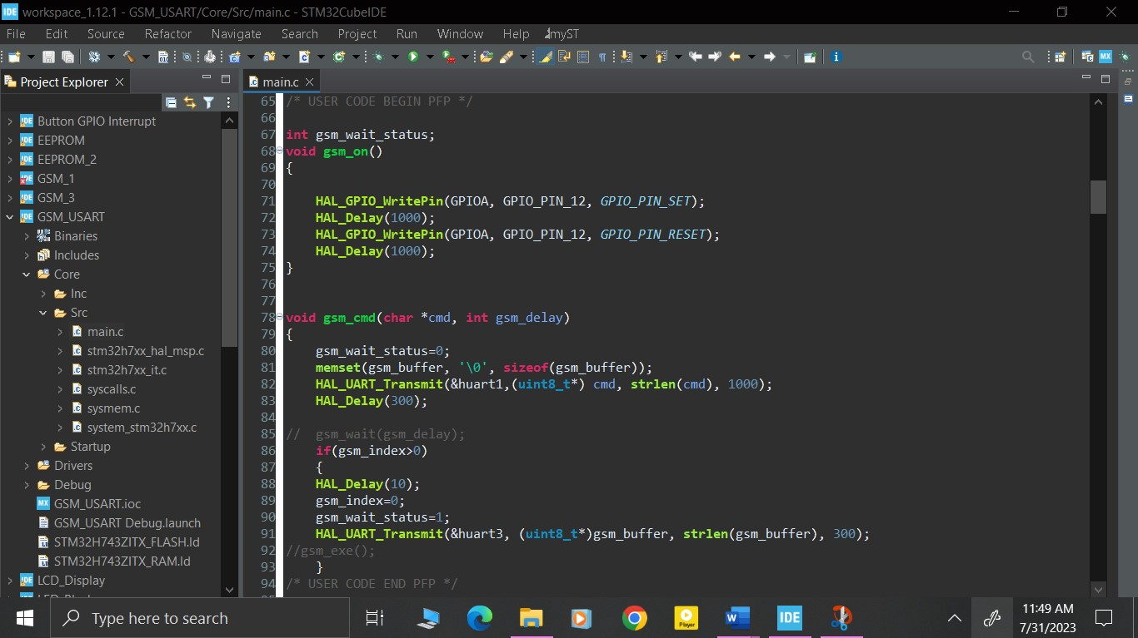

Student’s Signature: …………………………… Date…………………………………………..

Comments by Lecturer/Supervisor:………………………………………………………………..

…………………………………………………………………………………………………………….

……………………………………………………………………………………………………………. Name: ………………………………………………………………………………………………

Signature:…………………………………….. Date……………………………………………..

**WEEKLY PROGRESS CHART (WEEK ENDING: ---ELEVEN---)**

|  |  |
| --- | --- |
| DAY | **DESCRIPTION OF WORK DONE** |
| MON | Understanding RS232 to UART conversion |
| TUES | Writing STM32CubeIDE code to enable RS232 to UART conversion |
| WED | Implementing RS232 to UART conversion |
| THUR | Correcting errors obtained during implementation of the RS232 to TTL conversion |
| FRI | Correcting remaining errors encountered during implementation of the RS232 to UART conversion |
| SAT | Report Writing |

## TRAINEES WEEKLY REPORT

## Additional code on top of STM32 generated code

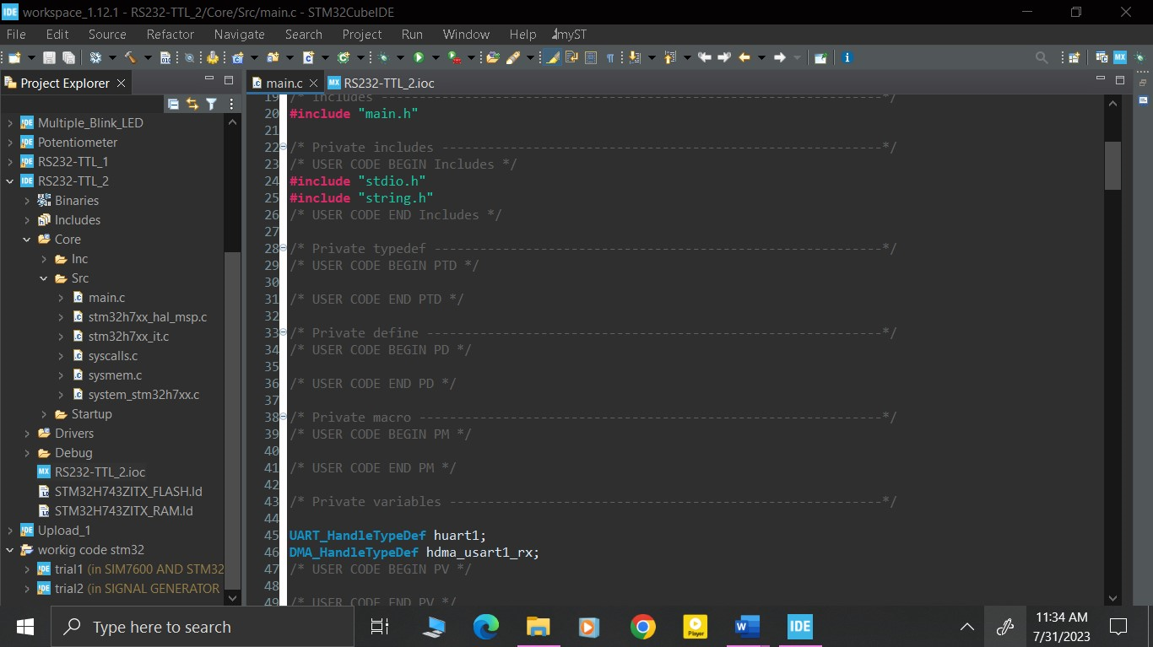

NOTE: USE BACK PAGE FOR THE CONTINUATION OF THE REPORT

## FOR SKETCHES, DIAGRAMS AND GRAPHS DATE………………..

(Additional drawings, may be attached where necessary) The student may also use this space for additional reports.

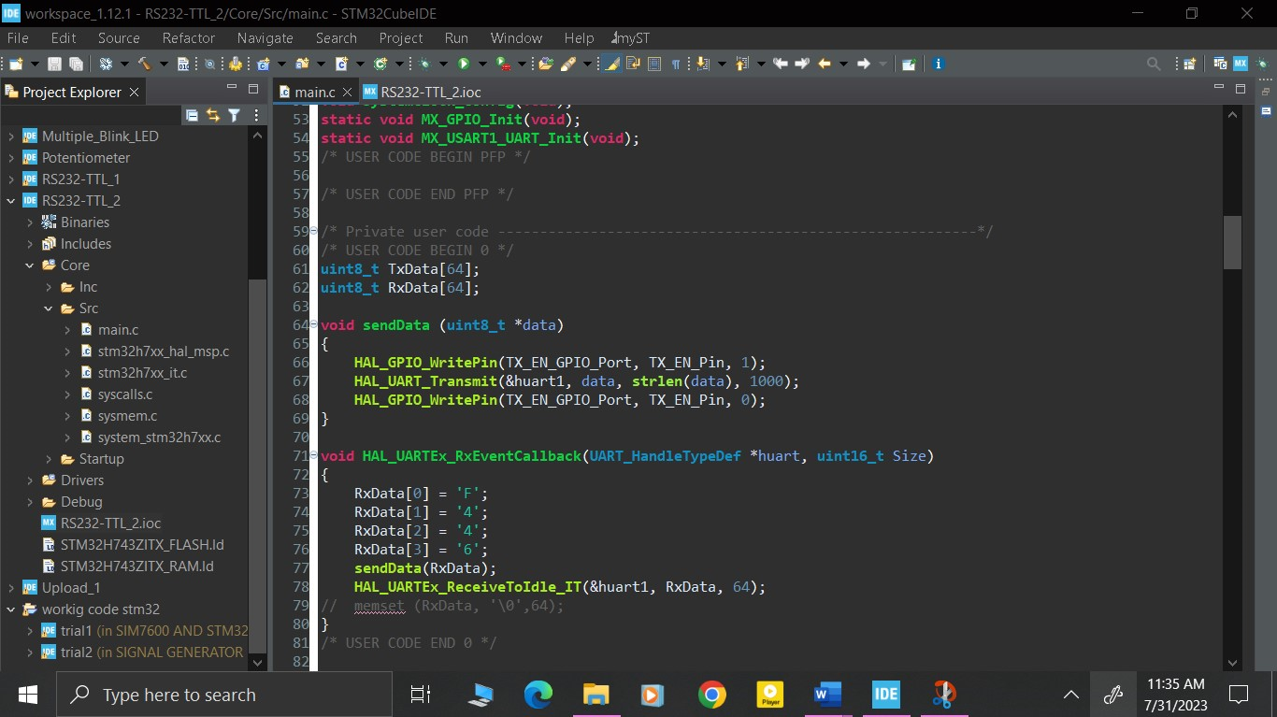

Student’s Signature: …………………………… Date…………………………………………..

Comments by Lecturer/Supervisor:………………………………………………………………..

…………………………………………………………………………………………………………….

……………………………………………………………………………………………………………. Name: ………………………………………………………………………………………………

Signature:…………………………………….. Date……………………………………………..

**WEEKLY PROGRESS CHART (WEEK ENDING: -----TWELVE )**

|  |  |
| --- | --- |
| DAY | **DESCRIPTION OF WORK DONE** |
| MON | Enduring speed limiter data is properly stored on the EEPROM |
| TUES | Ensuring that the GSM module was working efficiently |
| WED | Combining all the code snippets, that is, speed limiter, cloud storage, EEPROM storage, constant  listening function and printing functions. |
| THUR | Correcting the errors encountered during combination of the code snippets |
| FRI | Correcting the remaining errors. |
| SAT | Report writing |

## TRAINEES WEEKLY REPORT

A combination of all code snippets was done to make it into one whole program. This brought about multiple errors and warnings and it took some time to correct the errors and clear the warnings.

NOTE: USE BACK PAGE FOR THE CONTINUATION OF THE REPORT

## FOR SKETCHES, DIAGRAMS AND GRAPHS DATE………………..

(Additional drawings, may be attached where necessary) The student may also use this space for additional reports.

Student’s Signature: …………………………… Date…………………………………………..

Comments by Lecturer/Supervisor:………………………………………………………………..

…………………………………………………………………………………………………………….

……………………………………………………………………………………………………………. Name: ………………………………………………………………………………………………

Signature:…………………………………….. Date……………………………………………..

# FOR THE USE OF THE INSTITUTION SUPERVISOR ONLY

General comments on first/second/third (delete as appropriate) Visit.

Name of the Supervisor: …………………………………………………………………………

Signature of the Supervisor:…………………………………………………………………….

Date: ………………………………………………………………………………………………..